What Do I Need to

Know/Expect for a Trip to the Diocese of Meru, Tanzania?

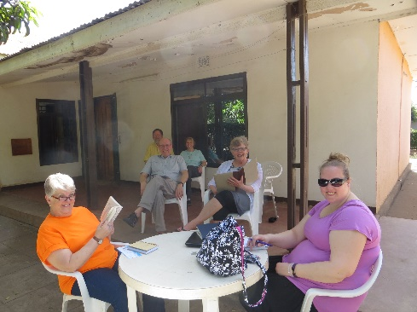 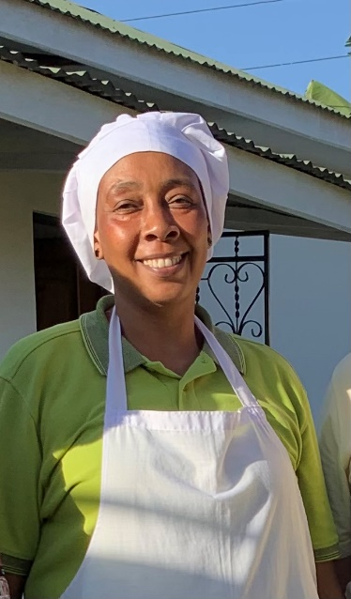

**NO PLASTIC BAGS!!!**

Hospitality & Warm Greetings!

Healthy Food including rice, vegetables, fruit, chicken, fish, and some meat (stew)

12 hours of sunlight and sporadic electricity

Dust! Bottled Water! Flavored Soda!

Bumpy Roads, slow travel, changing schedules

(a need for flexibility)

Meeting Gracious Hosts, People of Faith, Being accompanied most of the time

Safari – WOW!

Being a Guest, women wearing skirts/dresses; men slacks

Patience!

Using Cash vs Plastic

Dessert is Fruit, rarity of cookies, cake, chocolates brought by you!!!

Budget (2-week Estimates):

Valid Passport (good for at least 6 months)

Tanzanian Travel Visa - $125

Airfare -$1,300 - $2,500 Group rate???

2 or 3-day Safari - $800-$900

Guest House lodging/meals - $350-$400

Cash Gift for Host Family - $25/day

Transportation - ??$200??

Offerings/Gifts - $200

Incidentals - $100-??

Travel Dr. Visit (before trip to receive shots, malaria meds, Ciprofloxacin) - $250+

To-Do Timeframe

Month of travel - Travel (2 weeks recommended)

1 month prior to travel – Get New US $20 bills

2 months prior to travel – Travel Dr. visit

3 to 4 months prior to travel – Apply online for travel Visa

6 months prior to travel – Letter of Invitation from Diocese of Meru

7 to 9 months prior to travel – Airline tickets/safari deposit

* For more information please contact:

*Meru Partnership Committee Exec. Committee*

*Andy Toth – andy.toth@dematic.com*

*Pr. Chris Manke – chris.manke@gmselca.org*

SAMPLE ITINERARY

Wed. afternoon – Depart for O’Hare, 8-hour flight via Amsterdam; 3 to 4-hour layover

Thursday Morning – 8-hour flight to Kilimanjaro Airport, Tanzania, arrive late evening, 45 min. drive to Usa River Guest House

Friday – Rest, Exchange money, buy bottled water, visit cultural center in arusha

Saturday – visit local market, Usa River rehab center

Sunday -worship, visit sub-parish, home visits

Monday – Tour nkoaranga hospital & orphanage, ailanga jr. seminary and telescope observatory

Tuesday – makumira coffee project, mishikomono vocational school, Observatory (Telescopes to Tanzania (evenings))

Wed-Friday – Safari to Tarangire National Park, Lake Manyara National Park, Ngorogoro Crater

Saturday/ Sunday – travel to parish partner for Worship, visits

Monday – Visit Goat Project recipients, Area secondary schools, sub-parishes

Tuesday – rest!!! late Afternoon – Depart Kilimanjaro Airport, 9-hour flight to Amsterdam, 4-to-5-hour layover, 8-hour flight to Chicago

Wednesday – Arrive O’Hare mid-afternoon, return to Milwaukee.

COMMON WORDS AND PHRASES

* Please (Tafadhali)
* Thank you (Asante Sana)
* You’re Welcome (Karibu)
* Hello (Jambo)
* Goodbye (Kwaheri)
* Yes (Ndiyo)
* No (La)
* Toilet (Choo)
* Toilet Paper (Karatasi ya choo)
* Water (Maji)
* Help (Kusaidia)
* Bishop (Askofu)
* Pastor (Mchungaji)
* Doctor (Daktari)
* Friend (Rafiki)
* Wife (Mke)
* Husband (Mume)
* Daughter (Binti)
* Son (Mwana)
* Child (Mtoto)
* Children (Watoto)
* Mother (Mama)
* Father (Baba)
* Beautiful (Nzuri)
* I am lost (Nimetopea)
* I am hurt (Nimeumia)
* I am happy (Nimefurahi)
* God bless you (Mungu Akubariki)
* May the lord be praised (Bwana Asifiwe)
* How much does it cost? (Ni pesa ngapi)

*Janet McGinty -* [jlmcginty@tds.net](mailto:jlmcginty@tds.net)

*Dave Chappell -* [dmcold007@gmail.com](mailto:dmcold007@gmail.com)

Ruthann Rohde - [ruthann.rohde@gmail.com](mailto:ruthann.rohde@gmail.com)

ADDITIONAL SUGGESTIONS:

* BE COURTEOUS!!! At a minimum:
  + Please (tafadhali)
  + Thank you (asante sana)
  + You’re Welcome (Karibu)
  + Smile!
* BE PATIENT!
  + They have a saying: you have the clocks, but we have the time.
  + Your itinerary is a suggestion that they will try very hard to follow, but remember that you’re on “Tanzania time”
  + Be aware though, if YOU cause a delay, it will stress them out because they’re trying hard to follow your itinerary
* BE HUMBLE!
  + You’re not in Kansas (or Wisconsin) anymore; Keep any negative or disparaging comments to yourself
* BE SMART!
  + Stay with the group – don’t wander off
  + Keep valuables hidden when traveling
  + Always keep your passport with you, preferably on your person
  + Drink only bottled beverages – be wary of drinks served with ice or juices that might be from concentrate (mixed with water)
  + Bring your Imodium and ciprofloxacin with you everywhere

BE ADVISED!

* + It is very likely that you will be served a roasted goat (head and all).
    - This is known as “King’s Cake,” prepared and served to honor you
    - It’s served cut into small pieces, so eat at least one small piece so as not to offend
    - It’s well cooked, and delicious!
  + Outside of the guest house toilets are rare, and toilets with running water even more rare
    - “Restrooms” are typically an outhouse with a hole in the ground – be prepared to squat!

What to bring? (2-3 suitcases allowed)

Cash! (Credit cards not accepted in most places)

Comfortable walking shoes, Brimmed hat, sunglasses, sun protection clothing, body wallet

Medications including anti-diarrhea, motion sickness, allergy, cold, sinus, prescription w/scrip, prescription anti-biotic

Portable/re-chargeable batteries for devices, camera in addition to phone, outlet adapters/VOLTAGE converters

Journal, reading material, small travel bible

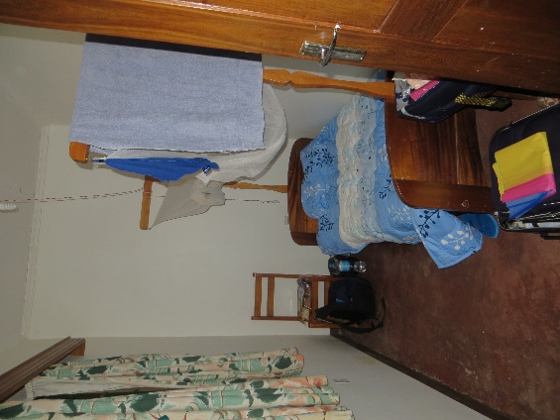shower shoes, flashlight, daypack, Nicer clothing for church, casual clothing for safari, small binoculars, small but personal gifts to share

Hand Sanitizer, Wet Wipes, Kleenex, Duct Tape, Multi-use tool, Soap, Hair Dryer/Curler, saltines

Battery operated clock

Clothes can be washed for a modest fee; Towels, Bed linens Provided

