Comfort Doll Knitting Pattern – adapted from Ravelry.com
Materials: Dark brown worsted weight, assorted bright colors for clothing
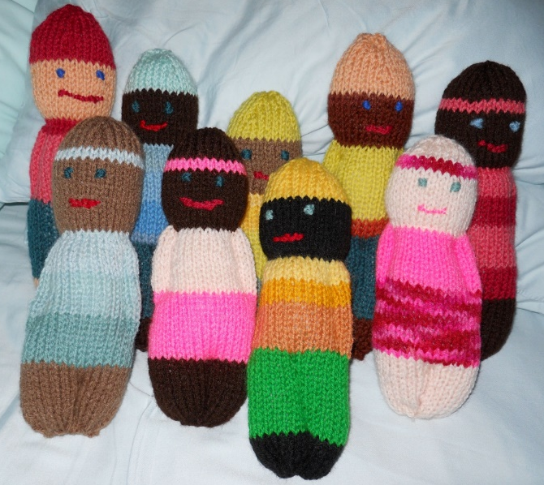
Needles – size 7 or 8; Yarn needle
Fiberfill for stuffing
To Begin: The basic method for making each doll is the same. Begin at the feet and knit a rectangle with a decrease at the top for a hat, (stockinette stitch-knit 1row, purl 1 row), changing colors for each body segment.
The head is stuffed and the neck formed by pulling in a gathering thread at the ankles. The arms and legs are defined by stitching through all layers after the doll is stuffed.
The number of rows in each section can be increased or decreased depending on the individual design. The finished height, as written, is about 5 inches.
To make: Work in stockinette stitch throughout. Cast on 32 sts.
Work 6 rows for feet. Change yarn.
Work 14 rows for pants. Change yarn.
Work 12 rows for shirt. Change yarn.
Work 8 rows for face. Change yarn.
Work 11 rows for hat as follows:
Rows 1-4: work evenly.
Row 5: Decrease 5 sts evenly across row (27 sts). Row 6 P across row.
Row 7: Decrease 5 sts evenly across row (22 sts). Row 8: P across row.
Row 9: Decrease 5 sts evenly across row (17 sts). Row 10: P across row.
Row 11: (K1, K2 tag), K last 2 sts.
Cut yarn leaving long tail to sew back. Draw yarn thru remaining stitches on needle and gather.
To finish:
- Fold inside out and sew down back to form center back seam. Turn right side out.
- Stuff head. Weave a strand of matching yarn thru 1st row of face. Gather in to form neck and secure ends.
- Repeat for body, drawing in at the ankles.
- Stuff feet and sew up bottom, gathering in as much as possible.
- With matching yarn, form arms with small stitches thru all layers from waist to 2 rows below necks. Define legs the same way, from bottom to just below waistline.
- Embroider hair and face as desired.
